**CS2023 - Data Structures and Algorithms**

**In-class Lab Exercise – Lab Report**

Week 5

By: Sajeev Kugarajah (210554M)

**Github directory link:**

<https://github.com/veejask-41/210554M-CS-2023-Data_Structures_And_Algorithms/tree/main/week%2005>

**Question 01)**

*SOURCE CODE IS UPLOADED TO THE GITHUB REPOSITORY*

Time taken for recursive quick sort algorithm in nanosecconds

|  |  |  |  |  |  |  |
| --- | --- | --- | --- | --- | --- | --- |
| arr size | test 1 | test 2 | test 3 | test 4 | test 5 | average |
| 5000 | 1040000 | 1506000 | 515000 | 2010000 | 510000 | 1116200 |
| 10000 | 1017000 | 8012000 | 1508000 | 3568000 | 3519000 | 3524800 |
| 15000 | 5073000 | 3513000 | 1700000 | 2764000 | 3010000 | 3212000 |
| 20000 | 3530000 | 6089000 | 4012000 | 512000 | 1709000 | 3170400 |
| 25000 | 6052000 | 2009000 | 506000 | 3535000 | 3400000 | 3100400 |

Time taken for iterative quick sort algorithm in nanoseconds

|  |  |  |  |  |  |  |
| --- | --- | --- | --- | --- | --- | --- |
| arr size | test 1 | test 2 | test 3 | test 4 | test 5 | average |
| 5000 | 505000 | 2130000 | 513000 | 2512000 | 4017000 | 1935400 |
| 10000 | 2512000 | 1024000 | 3025000 | 4011000 | 6384000 | 3391200 |
| 15000 | 2028000 | 4011000 | 5188000 | 4012000 | 3512000 | 3750200 |
| 20000 | 508000 | 2028000 | 4980000 | 3041000 | 3055000 | 2722400 |
| 25000 | 3677000 | 3846000 | 5520000 | 8098000 | 3409000 | 4910000 |

Timing plot using average times

|  |  |  |
| --- | --- | --- |
| arr size | recursive | iterative |
| 5000 | 1116200 | 1935400 |
| 10000 | 3524800 | 3391200 |
| 15000 | 3212000 | 3750200 |
| 20000 | 3170400 | 2722400 |
| 25000 | 3100400 | 4910000 |

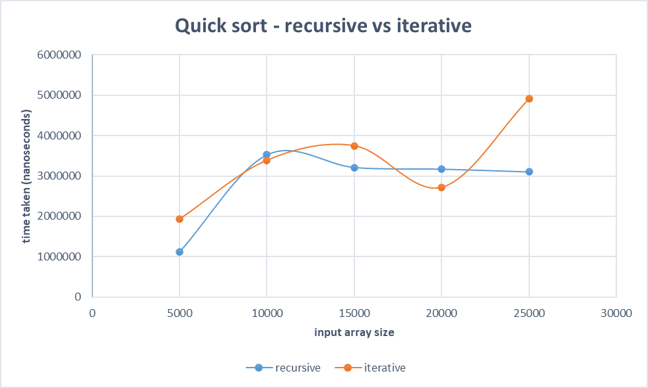

Discussion

This graph illustrates that both of the recursive and iterative algorithms are taking approximately equal time except in some cases. And time taken for both algorithms are increasing with increase of array size.

In some cases iterative algorithm is taking a longer time to sort the array, the array which was inputted was already partially sorted can be a valid reason for that because recursive algorithm works more efficient for partially sorted arrays than iterative algorithm as it is using divide and conquer method, partitioning the whole array.And for largest input sizes with worst cases, the iterative algorithm will be faster as it is avoiding the stack overhead unlike recursive algorithm.

Both of the quick sort algorithms have same worst and average case time complexity of o(n.logn) and o(n2).

**Question 02)**

*SOURCE CODE IS UPLOADED TO THE GITHUB REPOSITORY*

Command line output

